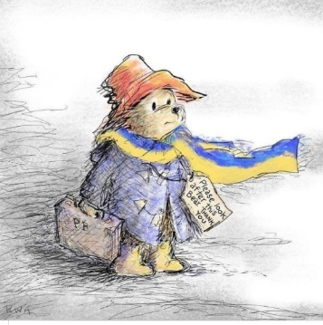 Supporting Ukrainian Refugees in School

It is easy to feel anxious about the responsibility of supporting refugee pupils in school. Whatever their past experiences, these students are likely to be attending classes not knowing anyone and without anyone speaking their own language. Transitions can be challenging for all pupils, and for children from refugee families, the challenge of fitting in is likely to be most acute. It is important to remember that when welcoming refugees the priority for both teachers and other school staff is the same as for all new children; to make them feel welcome, to provide support, to encourage friendships, and make sensitive assessments about their strengths and needs. With that in mind, please see below for some useful links to help meet these goals:

The Bell Foundation provides advice and guidance on supporting the needs of refugees. Their website is particularly useful, although you may need to register to access the materials (this is a quick and easy process and is free of charge.)

Welcoming refugee and asylum seeking learners (bell-foundation.org.uk)

Welcoming Refugee Children: Advice and Guidance for Schools 1 - The Bell Foundation (bell-foundation.org.uk)

Welcoming Refugee Children: Advice and Guidance for Schools 2 - The Bell Foundation (bell-foundation.org.uk)

Welcoming Refugee Children: Advice and Guidance for Schools 3 - The Bell Foundation (bell-foundation.org.uk)
The Refugee Week pack is helpful in providing resources to promote empathy among peers:

Children and young people pack Refugee Week 2022.pdf - Google Drive

The City of York Educational Psychology Service has provided a useful mind map (see below) covering the different areas and possible resources to consider :
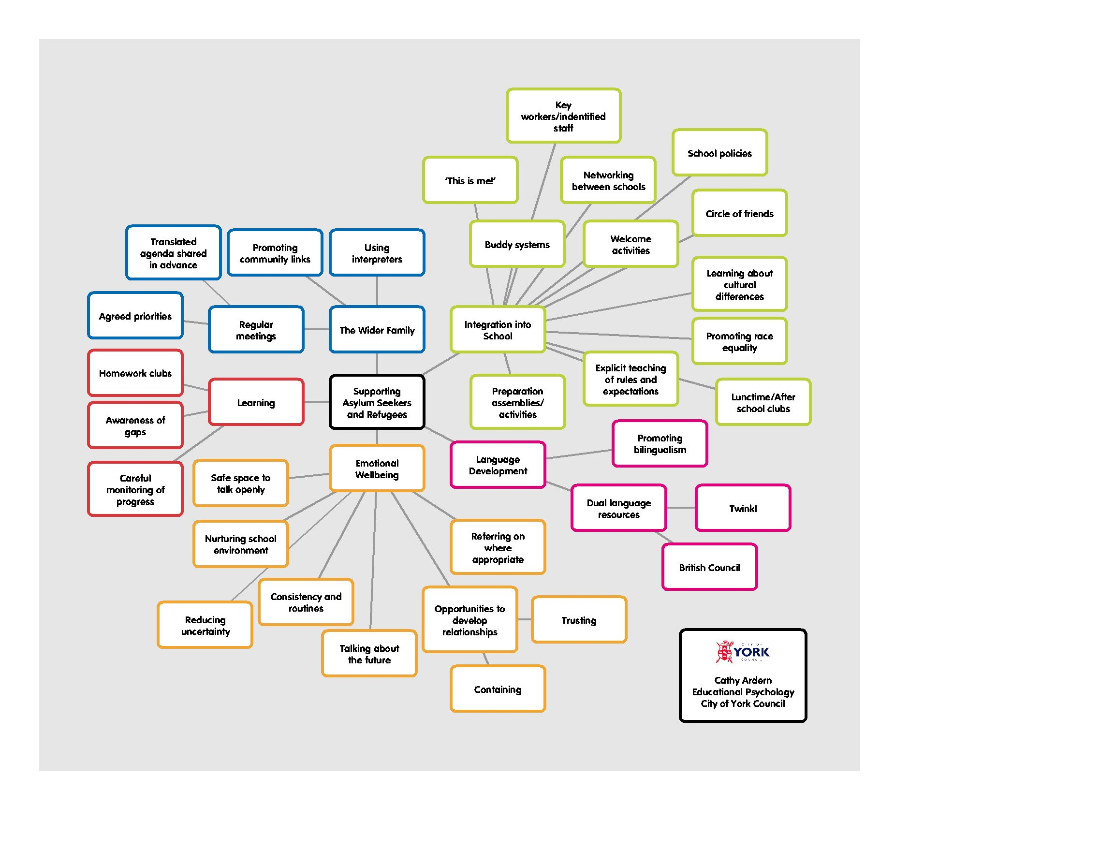

Finally, also from The City of York Educational Psychology Service, a dual language booklist (Ukrainian-English) containing books that can be used with young children (please see Appendix 1).

With grateful acknowledgements to The City of York Council Educational Psychology Service, Counterpoint Arts, and The Bell Foundation.

Dr E Bean, West Sussex County Council, August 2022.

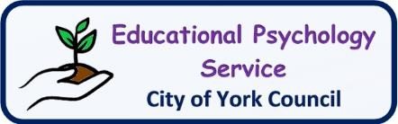
Appendix 1: Dual Language Books:
The following books can be purchased as dual language Ukrainian-English editions from stores such as Amazon, Waterstones and WH Smith:
- Amanda’s Dream, Admont (2020). ISBN: 9781525939549
- The Wheels: The Friendship Race, Nusinsky (2020). ISBN: 9781525933561
- Sweet Dreams, My Love, Admont (2021). ISBN: 9781525946813
- Boxer and Brandon, Nusinsky (2020). ISBN: 978-1525920752
- I Love to Help, Admont (2017). ISBN: 978-1525905773
- I Love to Brush My Teeth, Admont (2016). ISBN: 9781772682281
- Being a Superhero, Shmuilov (2020). ISBN: 978-1525932373
- Am I Small? (picture book), Winterberg (2014). ISBN: 978-1494874018
- I Love Autumn, Admont (2020). ISBN: 978-1525933196
- I Love Winter, Admont (2021). ISBN: 978-1525947179
- Egbert Turns Red (picture book), Winterberg (2021). ISBN: 9781517107383
- In Here, Out There (picture book), Winterberg (2015). ISBN: 9781517106959
- I Love to Share, Admont (2020). ISBN: 978-1525943850
- I Love to Keep my Room Clean, Admont (2021). ISBN: 9781525949937
- Dylan’s Birthday Present, Dias de Oliveira Santos (2020). ISBN: 9781952451973
- Jojo’s Easter Hunt, Lalgudi (2014). ISBN: 1508969787
- Sleep Tight, Little Wolf, Renz (2015). ISBN: 9783739926964
- Bedtime Fairy Tales, Bagdasaryan (2017). ISBN: 978-1548234096
- Who Lives in the Wood?, Chatty Parrot (2020). ISBN: 979-8554303197

English-Ukrainian & Ukrainian-English One-to-One Dictionary (exam-suitable):
(2nd edition), Volobuyeva (2018). ISBN: 978-1912826025

