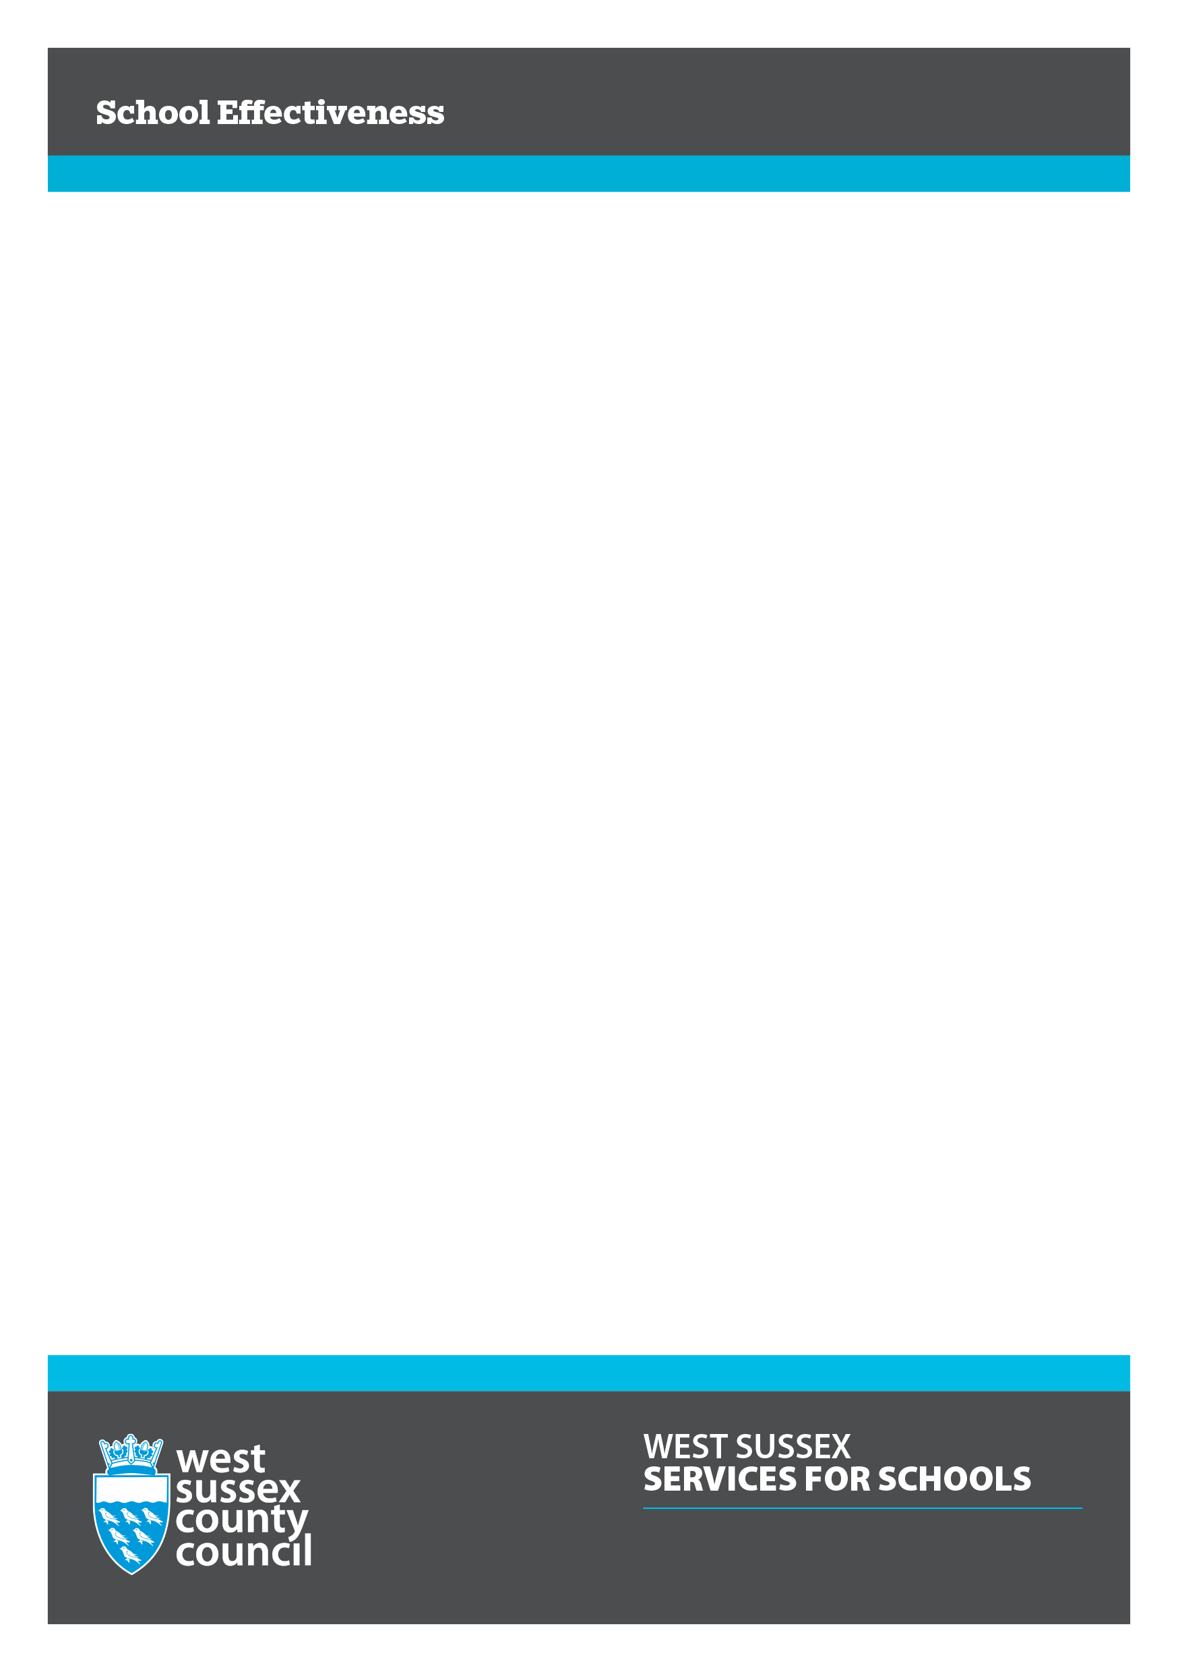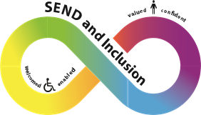

**SENCO Leadership Forums**

***Every leader is a leader of SEND and inclusion***



**FOCUS for the SPRING TERM**

**National Assocation for Special Educational Needs (NASEN)**

In response to your feedback for specific practical ideas we’re pleased to welcome our 3 colleagues from NASEN who will be sharing free resources to support you in your work. Following the session, you will have access to these resources to adapt for personal use.

**Ethnic Minority and Traveller Achievement Service (EMTAS)**

Olly Davidson will outline the current offer from his team, including recent developments such as remote training packages, targeted projects for EAL pupils, transition support for pupils from Gypsy, Roma & Traveller communities and a broadening focus to look at the wider experience of children from different BAME backgrounds.

EMTAS are keen to develop stronger network and locality support across the county.

The SENCO Leadership Forums are led and facilitated by the SEND and Inclusion Link Advisers. They are free and open to all West Sussex SENCos, Inclusion leaders, Teachers in Charge of SSCs and Senior Leaders from primary and secondary.

The Forums will be held on Zoom between 2.00pm – 4.00pm, please sign up to the session that’s most convenient for you.

Book on West Sussex Services for Schools via the links below;

[Tuesday 2nd February](https://schools.westsussex.gov.uk/T128248)

[Thursday 4th February](https://schools.westsussex.gov.uk/T128249)

[Thursday 11th February](https://schools.westsussex.gov.uk/T128250)

[sendinclusionsolutions@westsussex.gov.uk](mailto:sendinclusionsolutions@westsussex.gov.uk)

**Who is it for?**

* Xxxx