**My name is……………and this is what helps me to **

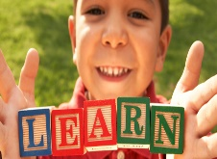



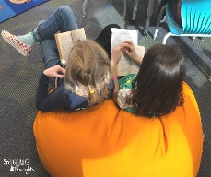

[This Photo](https://www.3rdgradethoughts.com/2019/01/classroom-organizing-challenge-january_14.html) by Unknown Author is licensed under [CC BY-ND](https://creativecommons.org/licenses/by-nd/3.0/)

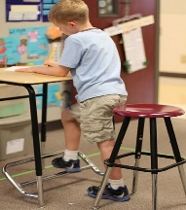

[This Photo](http://spring.org.uk/2015/04/tested-whether-people-think-better-on-their-feet-or-seated.php) by Unknown Author is licensed under [CC BY-NC](https://creativecommons.org/licenses/by-nc/3.0/)



[This Photo](http://www.orientacionandujar.es/2015/08/03/300-dictados-para-primaria-repasa-con-tus-hijos-e-hijas-incluye-reglas-ortografia/) by Unknown Author is licensed under [CC BY-SA-NC](https://creativecommons.org/licenses/by-nc-sa/3.0/)

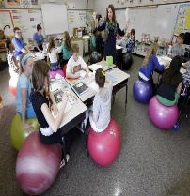

[This Photo](https://mrsdclasses.blogspot.com/) by Unknown Author is licensed under [CC BY-SA-NC](https://creativecommons.org/licenses/by-nc-sa/3.0/)

**Sitting at a table Standing at a table Laying on the floor Sitting on a cushion**

**Sitting alone Sitting with a friend Sitting with a group**

**Sitting near the whiteboard Sitting near the teacher Sitting at the back**

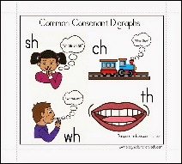

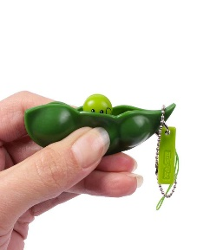

[This Photo](http://www.dudeiwantthat.com/style/accessories/squeeze-a-bean-edamame-fidget-toy-keychain.asp) by Unknown Author is licensed under [CC BY-SA-NC](https://creativecommons.org/licenses/by-nc-sa/3.0/)

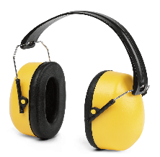

[This Photo](http://pngimg.com/download/7625) by Unknown Author is licensed under [CC BY-NC](https://creativecommons.org/licenses/by-nc/3.0/)

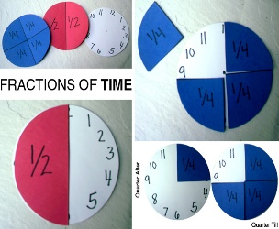

[This Photo](http://eisforexplore.blogspot.com/2012/05/fractions-of-time.html) by Unknown Author is licensed under [CC BY-NC](https://creativecommons.org/licenses/by-nc/3.0/)

**Fiddle to focus objects Doodling Headphones Visual prompts Timers**



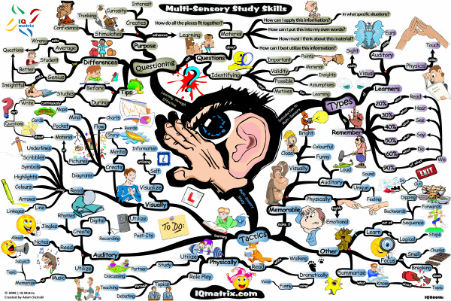

[This Photo](http://hspplus.blogspot.com/2016/06/come-to-your-senses.html) by Unknown Author is licensed under [CC BY](https://creativecommons.org/licenses/by/3.0/)

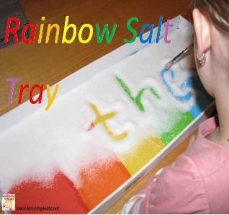

[This Photo](http://blogdelosmaestrosdeaudicionylenguaje.blogspot.com/2012/11/materiales-del-blog-learning-4-kids.html) by Unknown Author is licensed under [CC BY-NC-ND](https://creativecommons.org/licenses/by-nc-nd/3.0/)

**Mind maps Working with art Working with technology**

**Researching the internet Finding facts in books Voice recording Making PowerPoints**

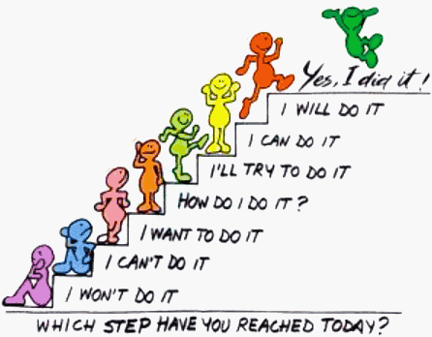

[This Photo](http://mycinnamonheart.blogspot.com/) by Unknown Author is licensed under [CC BY-NC-ND](https://creativecommons.org/licenses/by-nc-nd/3.0/)

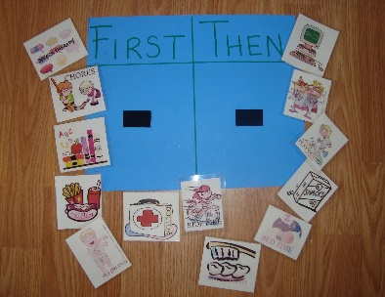

[This Photo](http://myausomeson.blogspot.com/2012/08/no-vs-first-then.html) by Unknown Author is licensed under [CC BY-NC](https://creativecommons.org/licenses/by-nc/3.0/)



[This Photo](https://en.wikibooks.org/wiki/File:VisualEditor_-_Icon_-_Number-list-ltr.svg) by Unknown Author is licensed under [CC BY-SA](https://creativecommons.org/licenses/by-sa/3.0/)

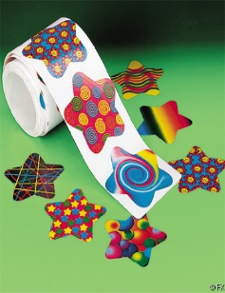

[This Photo](https://photomatt7.wordpress.com/2011/12/04/so-why-dont-you-give-me-a-sticker/) by Unknown Author is licensed under [CC BY-NC-ND](https://creativecommons.org/licenses/by-nc-nd/3.0/)

**Breaking things down into steps Stickers Praise Teacher coming over to me**

**Having things organised**

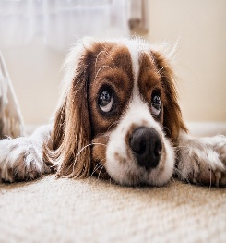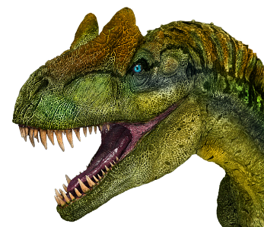



[This Photo](https://pt.wikipedia.org/wiki/Harry_Potter_e_a_Pedra_Filosofal) by Unknown Author is licensed under [CC BY-SA](https://creativecommons.org/licenses/by-sa/3.0/)

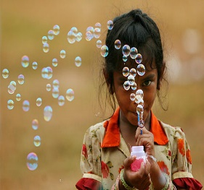

[This Photo](http://leadershipfreak.wordpress.com/2012/07/17/something-harder-than-believing-in-yourself/) by Unknown Author is licensed under [CC BY](https://creativecommons.org/licenses/by/3.0/)

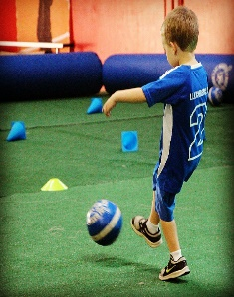

[This Photo](https://www.flickr.com/photos/brendan-c/9326243903) by Unknown Author is licensed under [CC BY](https://creativecommons.org/licenses/by/3.0/)

**Using my interests Being given choices about my learning Having work breaks**

**Having somewhere to go when my feelings get too much**

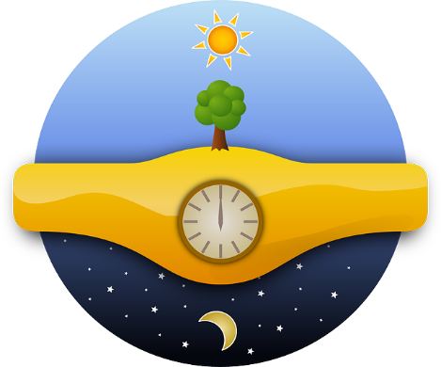**When do you learn best?**

**Anything else?**

