

**Autism and Social Communication Team**

**CUES:** **Coping with Uncertainty in Everyday Situations**

**A course for parents of autistic children or social communication differences**

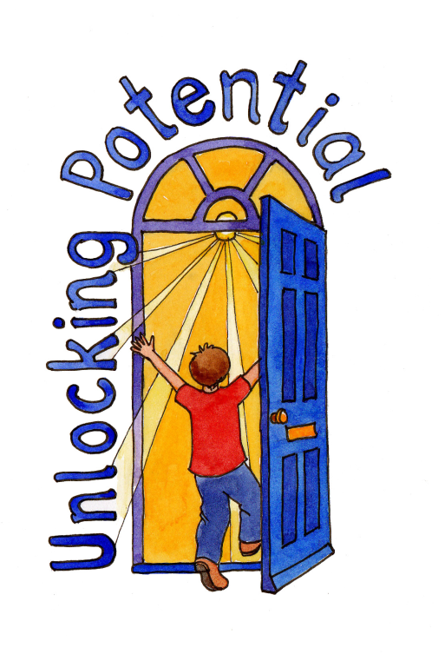

**Course outline:**

The CUES© intervention consists of **eight** parent group sessions.

Each session lasts **two hours** and will take place about a week apart.

The focus of the CUES© intervention is to increase parents’ knowledge of intolerance of uncertainty (IU).

The aim is to support parents in gaining confidence in their ability to recognise and manage their child’s IU through group learning opportunities.

Each parent will be provided with a range of strategies to try to help their child cope in uncertain situations and be able totolerate uncertainty more effectively.

The strategies used will depend on their child’s strengths and difficulties, preferences and personal habits.

It is hoped that by increasing parents’ understanding of IU and knowledge of strategies, the impact of IU on the child and family will be reduced.

**CUES— Coping with Uncertainty in Everyday Situations**

Are you a parent/carer of a child or young person, aged 6-16 years, who has autism or social communication differences?

The CUEs course is an excellent source of information for those who would like to develop strategies to help support their child/ren to cope with intolerance of uncertainty (IU) in everyday situations. The course is free of charge to families of children in West Sussex maintained schools, at this time.

**Course Aims:**

* To understand intolerance of uncertainty (IU) and how it relates to autistic children
* To work with parents to identify individually meaningful situations to focus on during the CUES© programme
* To help to identify helpful strategies to manage IU and increase tolerance to uncertainty
* To help to identify and reduce less helpful strategies that children might sometimes engage in during uncertain situations
* To develop a repertoire of helpful strategies to provide a more flexible approach to managing and increasing tolerance to IU
* To promote the use of helpful strategies to increase children’s tolerance of uncertainty

**We will be delivering this training at various times throughout the academic year, both in person, and face to face.**

**There will be a limited number of spaces available for parent/carers to attend twilight sessions and we hope everyone interested is able to find a convenient time to attend.**

**Times, dates and venues (for face to face sessions) are yet to be confirmed, but to express an interest in attending this course, or for any further information, please email:**

**Victoria.andrews@westsussex.gov.uk**

**Session 1:** **Getting to know each other** -gain an overview of the programme, get to know the members of the group and hear about their children, begin to gain an understanding of intolerance of uncertainty (IU), begin to think about how IU might affect how we feel, think and behave and to introduce a way to record IU, focusing on the triggers, emotions and behaviours.

**Session 2: Uncertainty and Autism –** begin to explore the consequences of being over-reliant on one strategy and consider whether this is less helpful and that developing a repertoire of strategies will help a child to adopt a more flexible approach to uncertainty, relate why intolerance of uncertainty (IU) might be such a key issue for autistic children and begin to think about how to introduce the concept of IU to children.

**Session 3: Getting in the Zone** -identify or reflect on chosen target situation, consider the importance of helping children to begin to grade their emotions by selecting an appropriate rating scale, think about small steps towards success, begin to think about helpful strategies, increase tolerance to uncertainty and introduce a way to record and review strategy use.

**Session 4: Practicing strategies using comic strip stories** – reflect on and plan for how to manage when attempts to use new strategies in uncertain situations do not go to plan and begin to plan using comic strip stories/ storyboards to assist with developing strategies to increase tolerance to uncertainty.

**Session 5: Practicing strategies through play/interests** – To start to think about extending a child’s approach to uncertain situations through the use of everyday play.

**Session 6: Using strategies in a real-life situation –** begin to consider which strategies each family has found helpful to support their child to become more tolerant of uncertainty, support parents to address their target uncertain situation and create a plan in which their child can test out strategies and begin to build up an evidence base to challenge their negative beliefs about uncertainty.

**Session 7: Are you in the zone?** - review how each family’s experiment went, consider what each family has learnt through planning, carrying out and reviewing an experiment about their child’s IU, think about how to continue using experiments to try new strategies and test a child’s negative beliefs about uncertainty.

**Session 8: Looking to the future –** review the CUES© programme, continue to think about next steps in helping children to increase their tolerance of uncertainty and to celebrate each family’s achievements during the CUES© programme.