Guidance on Provision Maps

The SEND Code of Practice states that:
- The provision made for pupils with SEN should be recorded accurately and kept up to date.
- Schools should particularly record details of additional or different provision made under SEN support which should form part of regular discussions with parents about the child’s progress, expected outcomes from the support and planned next steps.
- Schools should ensure that they have accurate information to evidence the SEN support that has been provided over the pupil’s time in the school, as well as its impact.
Provision maps are an efficient way of showing all the provision that the school makes which is additional to and different from that which is offered through the school’s curriculum. Provision maps can help SENCOs to maintain an overview of the programmes and interventions used with different groups of pupils and provide a basis for monitoring the levels of intervention. They can also be used strategically to develop special educational provision to match the assessed needs of pupils across the school, and to evaluate the impact of that provision on pupil progress.

All Settings are asked to provide costed provision maps demonstrating how the school has utilised its resources to make provision. This must clearly show purposeful, evidence-based provision costing at least the £6000 threshold from the notional SEN budget.
When completing provision maps for individual children, please ensure that you include the following:
- The type of intervention
- How the intervention links to the outcomes
- The weekly plan/timetable for the child/young person which must indicate/specify:
  - Number of sessions per week
  - The length of each session
  - Who is delivering the intervention (TA, HLTA, SALT, Specialist Teachers)
  - The size of the teaching group, indicating whether it is in class, in a small group (specify the size of the group) or on an individual basis.
- Please ensure that for group interventions, you calculate the cost per child. You must show annual costs.
- The individual costed provision map needs to map the learners support against their weekly timetable. You must include particular interventions that are over and above the ordinarily available provision. These interventions must be relevant and purposeful and specific to the primary and secondary needs of the children/young people.
*You cannot include class teacher time and SENCO time*

Please see some examples of costed provision maps below.
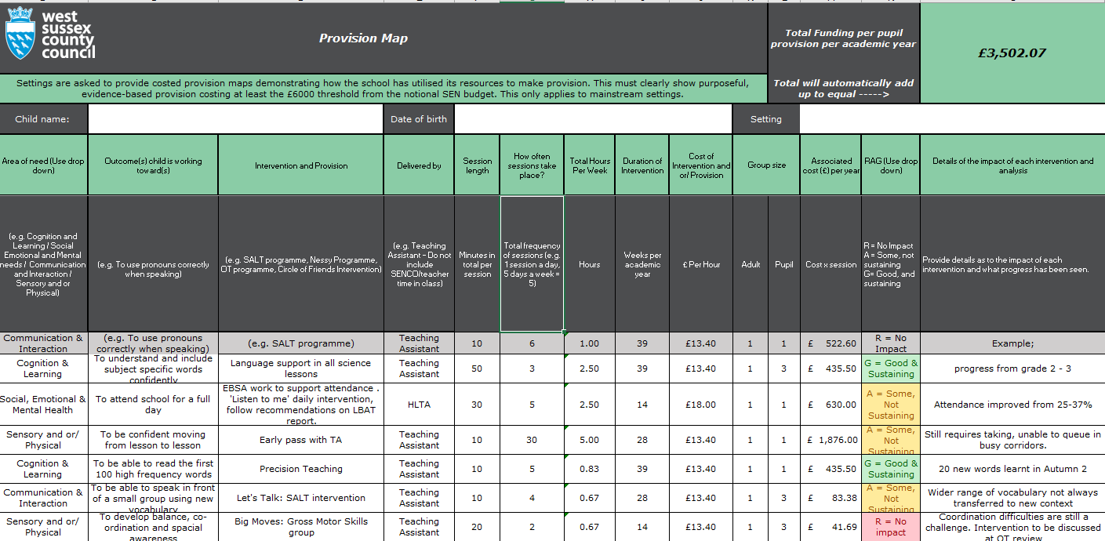
Day | Meet and greet | Session time/type  9.15am | Break  10.30am | Session time/type  10.45-12pm | Lunch | Session time/type | Total  Hours | Individual  hours | Cost per hour  £ | Total Cost  £ | Cost per week
Monday | 8.45 – 9:15  LM 1:1  Settling activity/ time to talk/ EBSA | 09.15 - 10.30 TA small group 1:3 literacy support to aid speech, language and concentration needs - support to focus on task. | 15 mins ELSA 1:1  (LM) | 10.45 - 11.45 classroom 1:2 TA support for maths:  Pre-teaching of topic vocab/Recap on previous learning/Misconceptions addressed | 30 mins 1:6 learning mentor (LM) support with outdoor games – social interaction and cooperation | 13.00 - 13.30 Speech and language programme 1:1 with SALT TA  13.30 - 14.45 In class small 1:5 group TA support Topic  Vocabulary/Breaking down instructions | 5.25 | TA 1 hr ÷ 2  TA 0.5 hrs ÷ 5  TA 1.25 hrs ÷ 2  TA 1 hr ÷ 3  TA 1 hr 1:1  LM 1.25 hrs  LM ÷ 6 for 0.5 hrs | 11.51  11.51  11.51  13.07  11.51  13.07  13.07 | 5.76  2.30  14.38  4.36  11.51  16.34  2.17 | 56.82
Tuesday | 8.45 – 9:15  LM 1:1  Settling activity/ Reading | 09.15 - 10.30 TA small group 1:3 literacy support to aid speech and language and concentration needs support to focus on task. | 15 mins -Supervised break  (not costed) | 10.45 - 11.45 classroom 1:2 TA support for maths:  Pre-teaching of topic vocab/Recap on previous learning/Misconceptions addressed | 30 mins 1:6 LM support with indoor games – social interaction and turn taking | 13.00 - 13.30 Gross Motor session 1:1 TA  13.30 - 14:30 PE Lesson  14:30 - 15:00 Social Story Puppet group 1:3 LM | 5.50 | TA 1 hr ÷ 2  TA 0.5 hrs ÷ 5  TA 0.5 hrs  TA 1.25 hrs ÷ 2  TA 1 hr ÷ 3  LM 1.25 hrs  LM 0.5 hrs ÷ 3 | 11.51  11.51  11.51  11.51  11.51  13.07  13.07 | 5.78  2.88  5.76  14.38  3.84  16.34  2.18 | 51.16
Wednesday | 8.45 – 9:15  LM 1:1  Settling activity/ Times tables | 09.15 - 10.30 TA small group 1:4 literacy support to aid speech and language and concentration needs support to focus on task. | 15 mins -Supervised playtime  (not costed) | 10.45 - 11.45 classroom 1:2 TA support for maths:  Pre-teaching of topic vocab/Recap on previous learning/Misconceptions addressed | 30 mins 1:6 LM support with indoor games – social interaction and turn taking | 13.00 - 13.30 Speech and language 1:1 session TA  13.30 - 14.45 In class small TA 1:5 group support Topic  Vocabulary/Breaking down instructions | 5.25 | TA 1 hr ÷ 2  TA 1 hr ÷ 4  TA 0.5 hr  TA 1.25 hrs ÷ 5  LM 1.25 hrs | 11.51  11.51  11.51  11.51  13.07 | 5.76  2.88  5.76  2.88  16.34 | 33.62
Thursday | 8.45 – 9:15  LM 1:1  Settling activity/ Spelling | 09.15 - 10.30 TA small group 1:3 literacy support to aid speech and language and concentration needs support to focus on task. | 15 mins -Supervised playtime  (not costed) | 10.45 - 11.45 classroom 1:2 TA support for maths:  Pre-teaching of topic vocab/Recap on previous learning/Misconceptions addressed | 30 mins 1:6 LM support with indoor games – social interaction and turn taking | 13.00 - 13.30 Fine Motor Session programme 1:1 TA  13:30 - 14:00 Social Communication group 1:3  Comic strips/ Social story  1400 – 14.45 TA 1:1 Post Learning consolidation | 5.25 | TA 1 hr ÷ 2  TA 1.75 hr ÷ 3  TA 0.75 hrs  TA 0.5 hrs  LM 0.75 hrs | 11.51  11.51  11.51  11.51 13.07 | 5.78  6.71  8.63  5.76  9.80 | 36.68
Friday | 8.45 – 9:15  LM 1:1  Settling activity/ time to talk/ EBSA | 09.15 - 10.30 Specialist Teacher small group 1:4 literacy support – Dyslexia Programme | 15 mins ELSA 1:1 | 10.45 - 11.45 classroom 1:2 TA support for maths:  Pre-teaching of topic vocab/Recap on previous learning/Misconceptions addressed | 30 mins 1:6 LM support with outdoor games – social interaction and cooperation | 13.00 - 13.30 Speech and language session 1:1 TA  13.30 - 14.45 In class small 1:5 group TA support Topic (Practical)  Vocabulary/Breaking down instructions | 5.25  Inc ST | TA 1.25 hr ÷ 4  TA 1 hr ÷ 2  TA 0.5 hrs  LM 1.25 hrs  LM 0.5 hrs ÷ 4 Specialist Teacher 1 hr. ÷ 4 | 11.51  11.51  11.51  13.07  13.07  28.32 | 3.60  5.78  5.78  20.43  1.63  7.08 | 44.30
Please note all TA time listed is costing for an extra TA not the class TA. |  |  |  |  |  | TOTALS | 26.50 |  |  |  | 222.58
 |  |  |  |  |  |  |  | TOTAL COST PER YEAR 222.58 x 39 |  |  | 8,680.62

