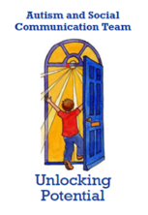
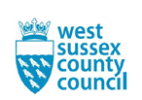
The ASC Team works with schools and families to promote the educational, social, and emotional development of children and young people with social communication needs including autism in West Sussex.

We are a small specialist team of Advisory Teachers and Specialist Learning Support Assistants who enable, challenge, and advise both maintained and mainstream schools and academies to be inclusive so that the best outcomes are achieved for children and young people with Autistic Spectrum Condition (ASC) and/or Social Communication Difficulties (SCD). The team provides individualised advice, support, and consultation to schools on a termly basis.
The ASCT supports and challenges schools through:
- Consultation and Review Meetings (CARMs).
- Observation visits.
- Bespoke transition support packages.
- A variety of training for school staff including Understanding Autism, Zones of Regulation, Sensory Processing Differences, Practical Classroom Strategies, Autistic Girls, Anxiety, Pupil Voice and the Autism Aware Award.
- Training for parents including the National Autistic Society’s EarlyBird Plus course, ASCSURE and CUEs training.
- Training for Trainee Teachers and Newly Qualified Teachers.
- Weekly Specialist Learning Support Assistant Advice Surgeries and Weekly Advisory Teacher Advice Surgeries.

As a team we love talking about all things Autism. We embrace people’s differences, celebrate the successes, encourage learning from mistakes and, most importantly, learn how to best support autistic people from our best resource, autistic people.

