**How to Book a SEND and Inclusion Review**

* Log into West Sussex Services for Schools (WSSfS)
* Click ‘Store’ on the bar at the top
* Click onto the ‘find a provider’ drop-down menu and select the SEN and Inclusion Service
* The SEND and Inclusion Review will then be listed as an option for purchase

You do need a certain level of access to be able to see the store – it may just be your School Business Manager who has the right level. If you have trouble, you can email our colleagues at [school.services@westsussex.gov.uk](mailto:school.services@westsussex.gov.uk) for technical support.

To make the review easier to find, here’s what it will look like on-screen:

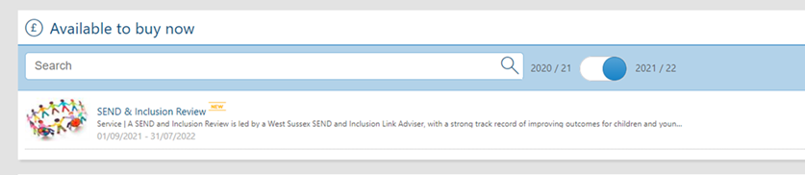

Once the system alerts us to a booking, we will get in touch with you personally to agree the date. No payment is taken until after delivery of the review.

Where possible, your review will be delivered by your Area SEND & Inclusion Adviser but could alternately be delivered by a different member of the team.

Area North: Claire Prince

Area Mid: Gemma Humphrey

Area South: Rachel McDonald-Taylor

Area West: Louise Burgess